**Assignment**

**JSF Web Application with MySQL and Mongo Databases**

Contents

Introduction 3

MySQL Database 3

Mongo Database 3

Marks 4

Skeleton 4

Submission of the Project 4

Overview of Web App 5

Main Page 5

List Countries Page 6

List Regions Page 7

List Cities Page 8

Full City Details Page 9

List Heads of State Page 10

Find Cities Page 11

Add Country Page 14

Add Region Page 15

Add City Page 16

Update Country Page 18

Delete Country Link 19

Add Head of State 20

Database Connectivity 21

### **Introduction**

Write a JSF dynamic web application that queries and updates a MySQL database and a Mongo database.

The MySQL database is called *geography* and can be downloaded from the *Project* section of Moodle for this module (*geography.sql*).

### MySQL Database

The *geography* database consists of 3 tables:

|  |  |
| --- | --- |
| **Country** | |
| **Column Name** | **Details** |
| co_code | A code representing the Country e.g. IRL, UK etc. |
| co_name | The Country name e.g. Republic of Ireland etc. |
| co_details | Details about the Country e.g. location, population, history etc. |

|  |  |
| --- | --- |
| **Region** | |
| **Column Name** | **Details** |
| co_code | A code representing the Country that the Region is part of |
| reg_code | A code representing the Region e.g. DUB, LON etc. |
| reg_name | The Region name e.g. Dublin, London etc. |
| reg_desc | Details about the Region e.g. location, population, history etc. |

|  |  |
| --- | --- |
| **City** | |
| **Column Name** | **Details** |
| cty_code | A code representing the City e.g. DUB, GAL etc. |
| co_code | A code representing the Country that the City is in |
| reg_code | A code representing the Region that the City is in |
| cty_name | The City name e.g. Dublin, Galway etc. |
| population | Whether the city is by the coast of not. (True or False) |
| areaKM | The area of the city in Kilometres |

Full details of the Primary and Foreign Keys as well as datatypes can be found in the database itself.

### Mongo Database

The Mongo database is called *headsOfStateDB* and consists of a collection called *headsOfState*, which initially has 3 documents as follows:

{ "_id" : "USA", "headOfState" : "Donald Trump" }

{ "_id" : "IRL", "headOfState" : "Michael D. Higgins" }

{ "_id" : "FRA", "headOfState" : "Emmanuel Macron" }

### **Marks**

This assignment is worth 50% of the marks for the module.

### **Skeleton**

A skeleton for this project (named GXXXXXXXX.zip) should be downloaded from the *Project* section of Moodle and used as a basis for this project.

### **Submission of the Project**

The zipped Eclipse project (named GXXXXXXXX.zip where GXXXXXXXX is your student number) should be uploaded to the *Project* section of Moodle no later than **Saturday December 9th 2017 at 9:00am.**

### **Overview of Web App**

The web app should consist of the following pages:

#### Main Page

The *Main* page simply consists of 5 links:

* One to the *List Countries* page
* One to the *List Regions* page
* One to the *List Cities* page
* One to the *List Heads of State* page
* One to the *Find Cities* page

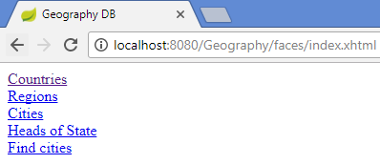

Figure 1 Main Page

#### List Countries Page

The *List Countries* page:

* Shows details of all Countries
* Has an *Add Country* button
* Has *Update* and *Delete* actions for each Country
* Has a link back to the *Main* page.

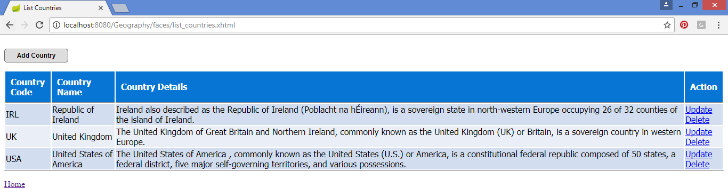

Figure 2 List Countries Page

#### List Regions Page

The *List Regions* page:

* Shows details of all Regions
* Has an *Add Region* button
* Has a link back to the *Main* page

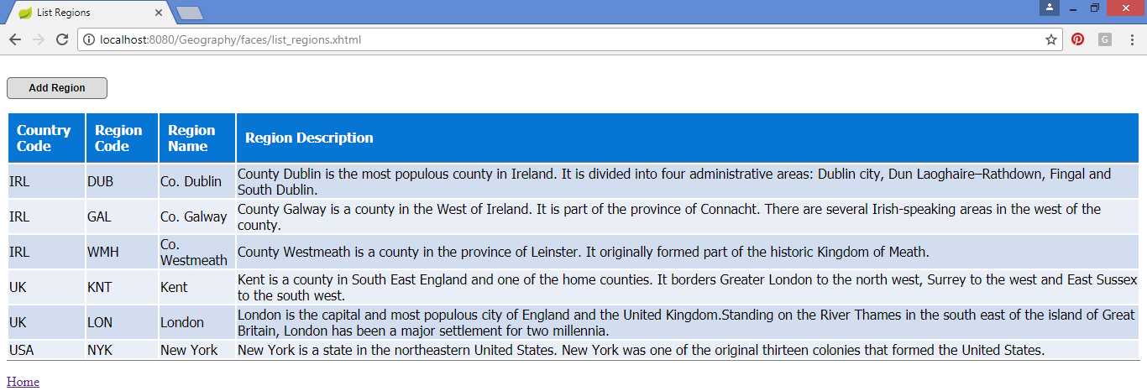

Figure 3 List Regions Page

#### List Cities Page

The *List Cities* page:

* Shows details of all Cities
* Has an *Add City* button
* Has an *All Details* action for each City
* Has a link back to the *Main* page

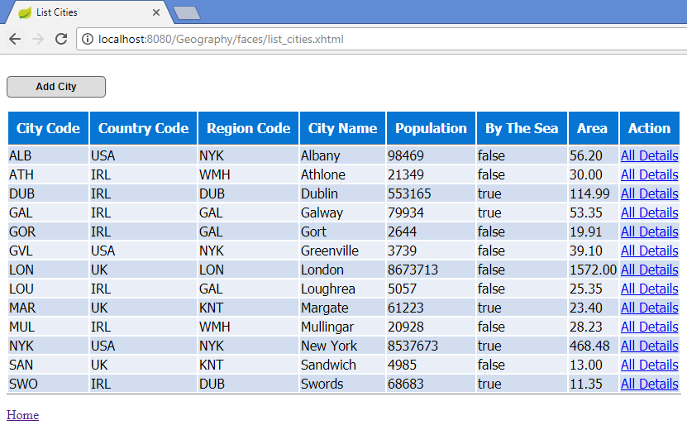

Figure 4 List Cities Page

#### Full City Details Page

The *Full City Details* page:

* Shows the *City Code, City Name, City Population,* whether the city is *Coastal*, and the *Area* of each city; as well as the *Country Name* and *Region Name* of the Country and Region the City is in.
* Has a link back to the *Main* page
* Has a link back to the *Cities* page

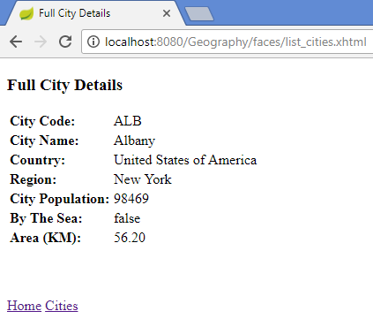

Figure 5 Full City Details Page

#### List Heads of State Page

The *List Heads of State Page* page:

* Shows details of all Heads of State
* Has an *Add Head of State* button
* Has a *Delete* action for each Head of State
* Has a link back to the *Main* page

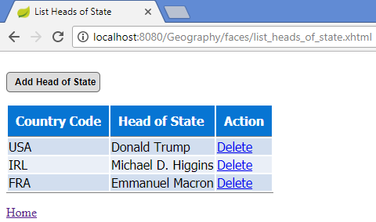

Figure 6 List Heads of State

#### Find Cities Page

The *Find Cities Page* page:

* Allows the user to search for Cities on the following criteria:
  + Population
  + Country Code
  + By The Sea
* Has a link back to the *Main* page

*Population* could be *Less Than, Greater Than* or *Equal To* a given value.

*Country Code* will be a String.

*By The Sea* will either be *True* or *False*.

If there are no values entered for *Population* or *Country Code*, these parameters are not searched on.

Figure 7 and Figure 8 show the results when only the *By The Sea* parameter is specified.

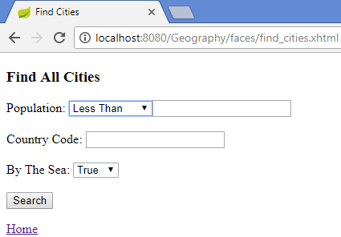

Figure 7 Find Cities Page - Search only on By The Sea

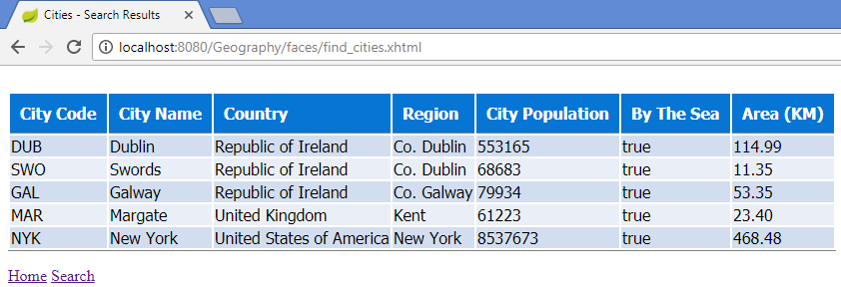

Figure 8 Find Cities Results Page - Search only on By The Sea

Figure 9 and Figure 10 show the results when only the *Population (Less Than)* and the *By The Sea* parameters are specified.

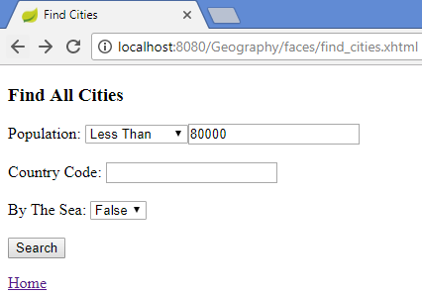

Figure 9 Find Cities Page - Search on Population and By The Sea

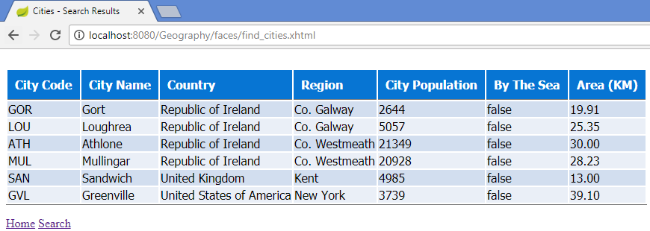

Figure 10 Find All Cities Results Page - Search on Population and By The Sea

Figure 11 and Figure 12 show the results when the *Population (Greater Than)*, *Country Code* and *By The Sea* parameters are specified.

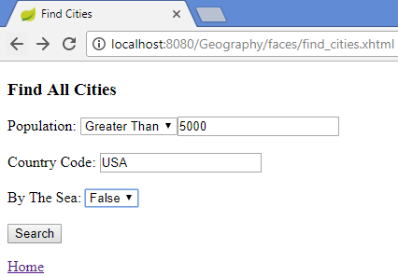

Figure 11 Find All Cities Page - Search Population, Country Code and By The Sea

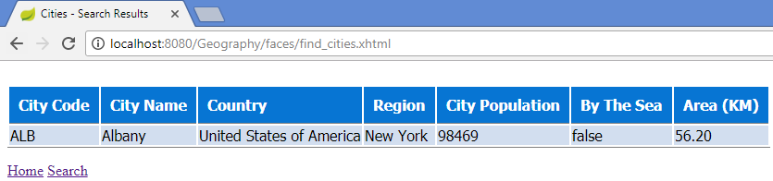

Figure 12 Find All Cities Results Page - Search Population, Country Code and By The Sea

#### Add Country Page

The *Add Country Page* allows the user to enter a Country Code, Name and Details.

If an existing Country Code is entered an error should be displayed.

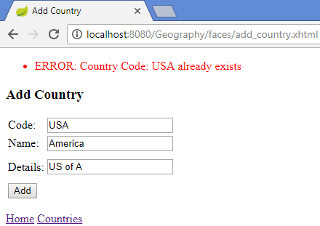

Figure 13 Country Code already exists

If a Country Code or Country Name is not specified an error is also shown:

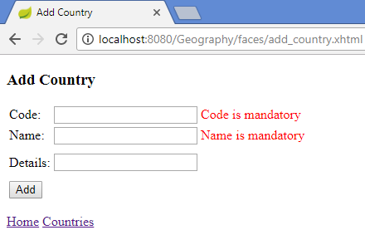

Figure 14 No Country Code or Country Name

When a Country has been added successfully, the user is returned to the *List Countries Page.*

#### Add Region Page

The *Add Region Page* allows the user to enter a Country Code, Region Code, Region Name and Description.

If a Country Code, Region Code or Region Name are not specified error messages are shown:

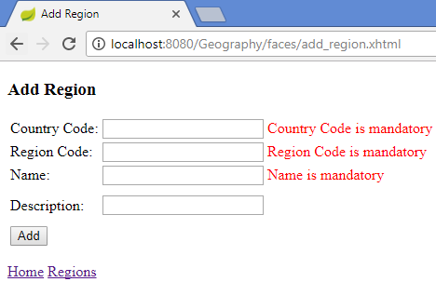

Figure 15 Country Code, Region Code, Region Name missing

If the user specifies a non-existent Country Code an error message is shown.

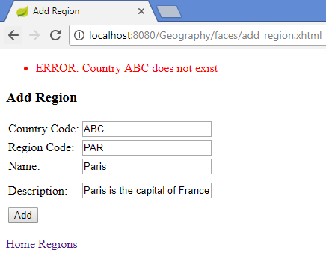

Figure 16 Country Code does not exist

When a Region has been added successfully, the user is returned to the *List Regions Page.*

#### Add City Page

The *Add City Page* allows the user to enter a City Code, Country Code, Region Code, City Name, City Population, whether the City is By The Sea and the area of a City.

If the City Code, Country Code, Region Code or City Name are not specified error messages are shown:

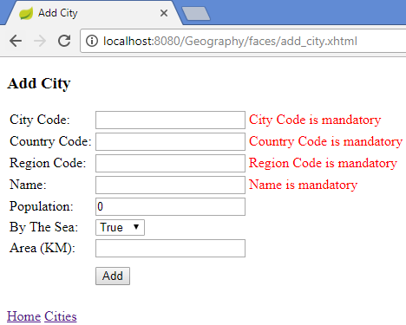

Figure 17 City Code, Country Code, City Code, City Name missing

If a correct Country Code, Region Code combination is not specified, or an invalid Country Code and/or Region Code is specified, an error message is shown:

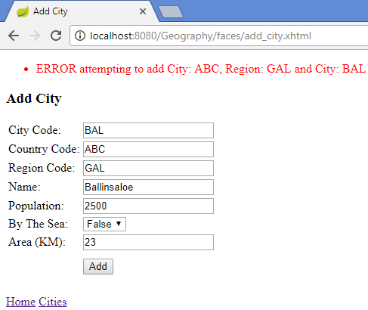

Figure 18 Invalid Country Code, Region Code combination

#### Update Country Page

The *Update Country Page* is opened from the *Update* action on the *List Countries* page.

The Country code cannot be updated, only the Name and Details. The Country Name is mandatory.

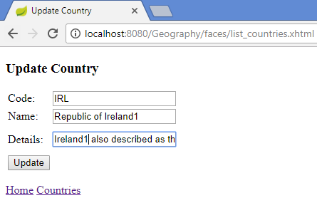

Figure 19 Update Country

#### Delete Country Link

When the user clicks on the *Delete* Country link on the *List Countries Page* he/she is presented with a confirmation dialog box:

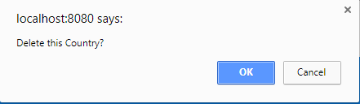

Figure 20 Delete Country Dialog

If the user clicks OK, the Country is deleted – unless it is referenced by a Foreign Key in another table – in which case an error is shown:

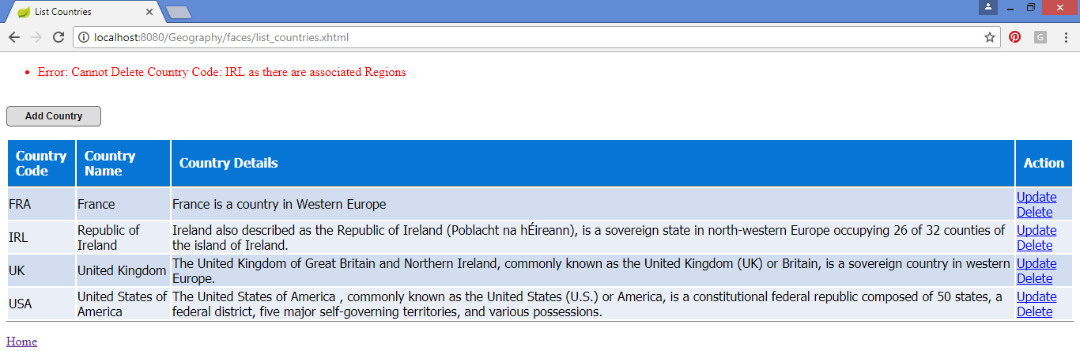

Figure 21 Cannot Delete Country

#### Add Head of State

The *Add Head of State Page* allows the user to enter a Country Code and a Head of State.

If a Country Code, Region Code or Region Name are not specified error messages are shown:

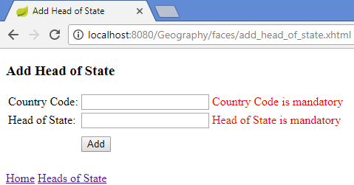

Figure 22 Country Code or Head of State missing

If a Country Code is entered that does not exist in MySQL database, an error message is shown:

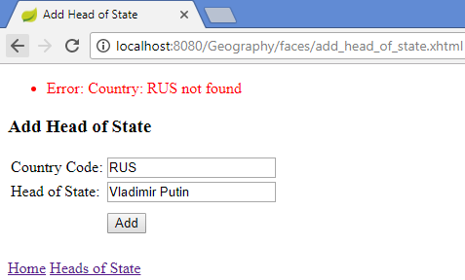

Figure 23 Invalid Country Code

When a valid Head of State has been entered, the user is brought back to the *List Heads of State Page*.

### **Database Connectivity**

If, when attempting to query or update a database, the database is unavailable (e.g. offline) an appropriate error message should be displayed.

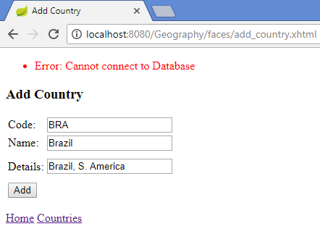

Figure 24 MySQL database unresponsive when attempting to Add Country

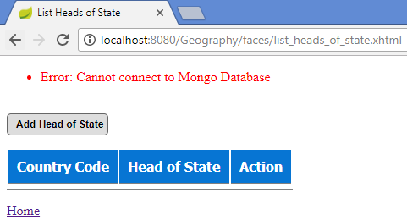

Figure 25 Mongo database unresponsive when attempting to List Heads of State